**Introduction To HTML 5 & CSS 3 (Web Designing)**

* Hypertext Markup Language was introduced in 1990.
* HTML 5 is the next version and will be the new standard.
* HTML 5 was recommended as a standard by W3C in 1997.
* Majority of the browsers support HTML 5 element and Application Programming Interface (API).

**Evolution Of Computing**

* Computing started by using stand-alone computers to perform different computing operations.
* Later organizations began to connect their computers to share data.

**Different types of networks are as follows:**

1. Local Area Network (LAN)
2. Metropolitan Area Network (MAN)
3. Wide Area Network (WAN)

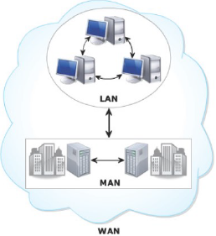

**Local Area Network (LAN)**

Network in a small geographical area.

**Metropolitan Area Network (MAN)**

Network that covers city.

**Wide Area Network (WAN)**

Network that connects LANs and MANs across the globe.

**Web & Internet**

* WAN raised the need to share data across the globe rather than within an organization.
* This resulted in the evolution of Web also known as World Wide Web (WWW).
* Internet is known as the largest WAN.
* Web is a way to access information using Internet.
* Multiple computers are connected to each other irrespective of geographical locations.

**Web Communication**

* Web pages are stored on a Web server to make them available on the Internet for the users.
* Web server is a computer with high processing speed and connected to the Internet.
* Web server is used to host and display the Web pages on a Web browser.
* Web browser displays the Web pages using the HTTP protocol.
* HTTP is a protocol that specifies how a Web page will be retrieved from the Web server.

**Steps to view a Web page in a browser are as follows:**

* User specifies the Uniform Resource Locator (URL) of Web page in a browser.
* The client browser sends the URL request to the appropriate Web server.
* Web server processes the request and sends the Web page as a response to the browser.

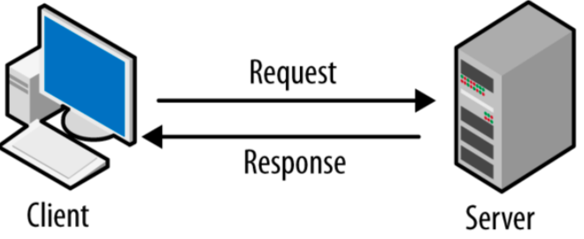

**There are 2 types of Websites / Web Pages**

1. **Static** Websites / Web Pages
2. **Dynamic** Websites / Web Pages

**Static Websites / Web Pages**

* Contents remain unchanged
* Consists of content such as text, images, videos and so on
* Simple to design as it provides no interactivity
* Focuses on content presentation

**Dynamic Websites / Web Pages**

* Allows customization of content and its appearance in browser
* Data is always up-to-date and reliable
* Generates content on-demand when user provides input
* Allows user interaction

**Technologies used for creating dynamic Websites are as follows**

* JavaScript, a scripting language, is used for creating dynamic Web pages.
* CSS specifies the formatting of a Web page for both static and dynamic Web pages.

**History**

HTML has evolved over the years with the introduction of improved set of standards and specifications

**HTML -> 3.0 -> HTML -> 3.2 -> HTML -> 4.0 -> HTML -> 5.0**

**Basic rules for HTML 5 are as follows**

* Introduction to new features should be based on HTML, CSS, DOM, and JavaScript.
* More markup (tags) to be used to replace scripting (Javascript).
* Must be device independent.
* Need for external plug-in to be reduced.
* Better error handling capabilities.
* Better visibility to public the development process.

**Layout of a Page in HTML 5**

* HTML 5 contains a head section containing the unseen elements and the body section containing the visible elements of the document.
* Earlier HTML provided different tags to build and organize the content in the body of the document.
* The **<table>** tag was an element often used to present the data in an organized manner.
* The **<div>** tag was another element used to display contents such as images, links, text, menus, forms, and so on.
* HTML 5 includes new elements that identify and organize each part of the document body.

**New & Flexible Approach of HTML 5**

* Provides new features in CSS such as advanced selectors, drop-shadows and so on
* Provides new features for mobile applications
* Gets rid of plug-in and uses native support for audio and video
* Provides descriptive semantics
* Provides client-side storage and caching functionality
* Uses the Web worker feature to make JavaScript efficient
* Helps to create rich Internet clients using plug-ins such as Flash

**New Features Of HTML 5**

* Web workers API is added to support background process without affecting the main process
* Web sockets API provides continuous connection between a server and a client
* **<canvas>** element used for drawing
* Content specific elements helps to structure the document
* Provides local storage support
* **<audio> & <video>** element available for media playback

**Cascading Style Sheet (CSS)**

* Works along with HTML to provide visual styles to document elements.
* Is a rule based language that specifies the formatting instructions for content in an HTML document.
* Purpose is to separate content from its formatting.
* Can define the layout and formatting of content in a separate file with a .css extension.
* Allows rules from different .css files to be merged or edited.

**Benefits Of CSS**

* Code Re-usability
* Less HTML code
* Device Independence